**SQL Exercise 1**

**1 create the table SEMP with the following structure:- EMPNO CHAR(4) EMPNAME CHAR(20) BASIC FLOAT DEPTNO CHAR(2) DEPTHEAD CHAR(4)**

mysql> create table SEMP(

-> empno char(4),

-> empname char(20),

-> basic float,

-> deptno char(2),

-> depthead char(4)

-> );

**2. Create the table SDEPT with the following structure:- DEPTNO CHAR(2) DEPTNAME CHAR(15)**

mysql> create table SDEPT(

-> DEPTNO CHAR(2),

-> DEPTNAME CHAR(15)

-> );

**3. Insert into the SDEPT table the following values:- 10, Development 20, Training**

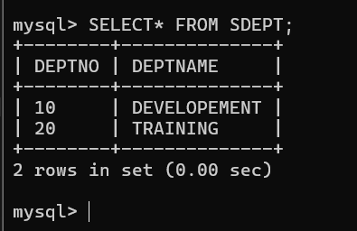

4**. Insert into the SEMP table the following values:- 0001, SUNIL, 6000, 10 0002, HIREN, 8000, 20 0003, ALI, 4000, 10, 0001 0004, GEORGE, 6000, 0002**

mysql> insert into SEMP(empno, empname, basic, deptno, depthead)values

-> ('0001', 'sunil' ,6000, '10', null),

-> ('0002', 'hiren' ,8000, '20', null),

-> ('0003', 'Ali' ,4000, '10', '0001'),

-> ('0004', 'george' ,6000, '20', '0002');

Query OK, 4 rows affected (0.02 sec)

Records: 4 Duplicates: 0 Warnings: 0

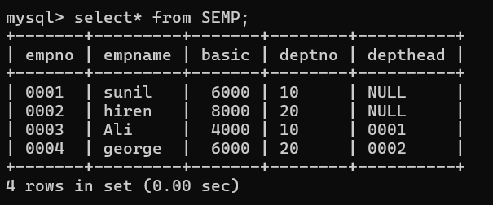

**Create S, P, J, SPJ tables as specified below and insert a few rows in each table:- SUPPLIER (S#, Sname, Status, City) –**

**S PARTS (P#, Pname, Color, Weight, City) –**

**P PROJECTS (J#, Jname, City) - J SUPPLIER-PARTS-**

**PROJECT (S#, P#, J#, Qty) –**

**SPJ Sample data for S# column:- ‘S1’, ‘S2’, ‘S3’, etc.**

**Sample data for P# column:- ‘P1’, ‘P2’, ‘P3’, etc.**

**Sample data for J# column:- ‘J1’, ‘J2’, ‘J3’, etc.**

**Sample data for Status column:- 10, 20, 30, etc.**

a) mysql> CREATE TABLE SUPPLIER(

-> `S#` CHAR(2),

-> Sname VARCHAR(20),

-> Status INT,

-> City VARCHAR(20)

-> );

Query OK, 0 rows affected (0.07 sec)

------------------

b) mysql> CREATE TABLE PARTS(

-> `P#` CHAR(2),

-> Pname VARCHAR(20),

-> Color VARCHAR(10),

-> Weight DECIMAL(5,2),

-> City VARCHAR(20)

-> );

Query OK, 0 rows affected (0.03 sec)

C) mysql> CREATE TABLE PROJECTS(

-> `J#` CHAR(2),

-> Jname VARCHAR(20)

-> City VARCHAR(20)

-> );

Query OK, 0 rows affected (0.03 sec)

------------------------------

D) mysql> CREATE TABLE SPJ(

-> `S#` CHAR(2),

-> `P#` CHAR(2),

-> `J#` CHAR(2),

-> Qty INT

-> );

Query OK, 0 rows affected (0.03 sec)

---------------

mysql> insert into SUPPLIER(`S#`,Sname,Status, City) values

-> ('S1', 'Supplier1' , 10, 'new york'),

-> ('S2', 'Supplier2' , 20, 'San francisco'),

-> ('S3', 'Supplier3' , 30, 'Los Angles'),

-> ('S5', 'Supplier5' , 50, 'Paris'),

-> ('S6', 'Supplier6' , 60, 'Athens');

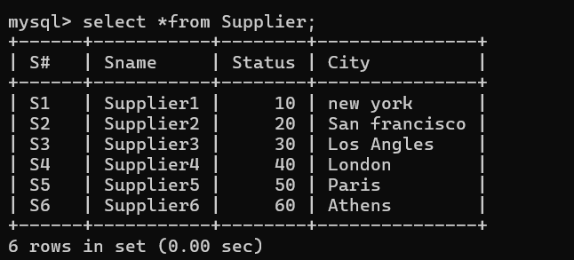

mysql> insert into PARTS(`P#` , Pname, color, Weight, City) values

-> ('P1', 'Part1' , 'Red', 12.5, 'new york'),

-> ('P2', 'Part2' , 'Blue', 10.0, 'San francisco'),

-> ('P3', 'Part3' , 'Green', 15.3, 'Los Angles');

Query OK, 3 rows affected (0.05 sec)

Records: 3 Duplicates: 0 Warnings: 0

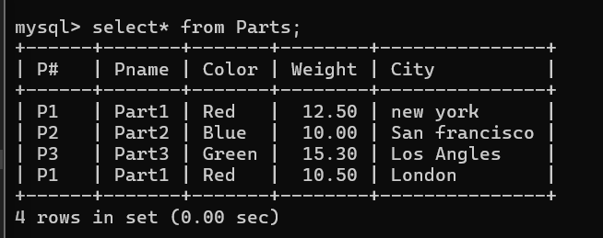

mysql> insert into PROJECTS(`J#`,Jname,City) values

-> ('J1', 'Project1' , 'new york'),

-> ('J2', 'Project2' , 'san francisco'),

-> ('J3', 'Project3' , 'Los Angles'),

-> ('J4', 'Project4', 'Athens');

Query OK, 3 rows affected (0.01 sec)

Records: 3 Duplicates: 0 Warnings: 0

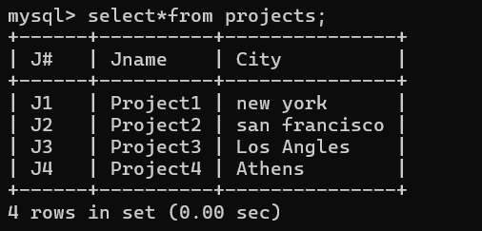

mysql> insert into SPJ(`S#`,`P#`,`J#` , Qty) values

-> ('S1', 'P1' , 'J1' , 100),

-> ('S2', 'P2' , 'J2' , 200),

-> ('S3', 'P3' , 'J3' , 150),

-> ('S1', 'P3' , 'J2' , 300);

Query OK, 4 rows affected (0.01 sec)

Records: 4 Duplicates: 0 Warnings: 0

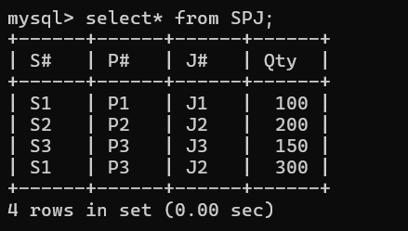

**Write the SELECT queries to do the following:-**

**5. Display all the data from the S table.**



**6. Display only the S# and SNAME fields from the S table.**

mysql> select `S#` , Sname from supplier;

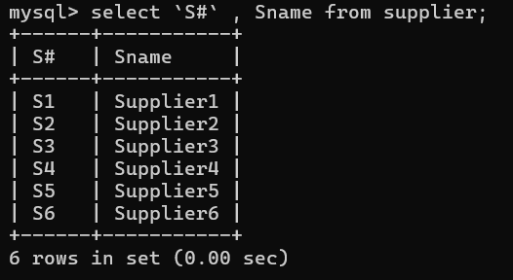

**7. Display the PNAME and COLOR from the P table for the CITY=”London”.**

mysql> select Pname , color

-> from PARTS

-> where City = 'London';

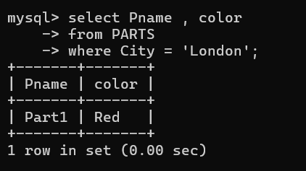

**8. Display all the Suppliers from London.**

mysql> select *

-> from Supplier

-> where City = 'London';

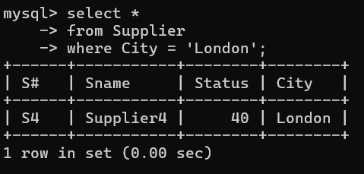

**9. Display all the Suppliers from Paris or Athens.**

mysql> select *from supplier

-> where city In ('paris' , 'Athens');

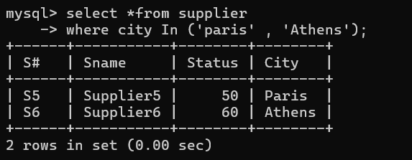

**10. Display all the Projects in Athens.**

mysql> select *from projects

-> where city = 'Athens';

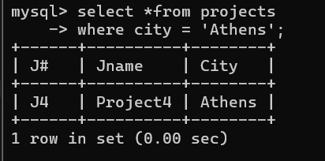

**11. Display all the Partnames with the weight between 12 and 14 (inclusive of both).**

mysql> select Pname

-> from PARTS

-> where Weight Between 12 and 14;

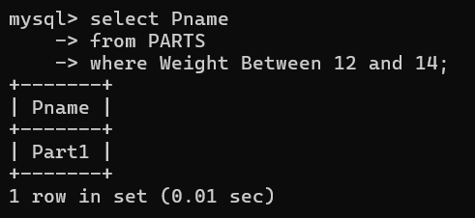

**12. Display all the Suppliers with a Status greater than or equal to 20.**

mysql> select*

-> from Supplier

-> where Status >= 20;

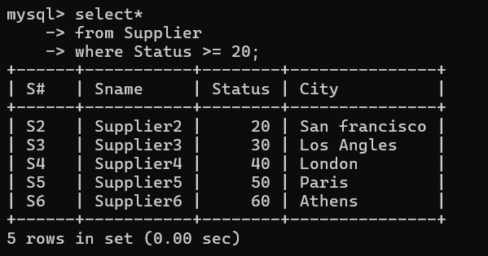

**13. Display all the Suppliers except the Suppliers from London.**

mysql> select*

-> from supplier

-> where City <> 'London';

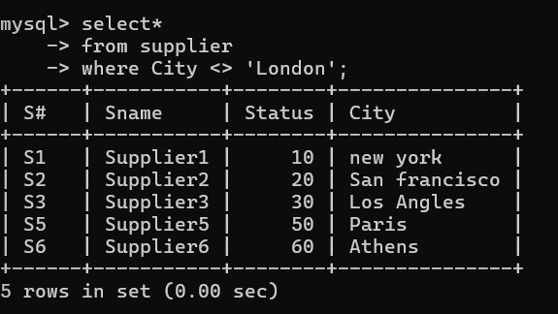

**14. Display only the Cities from where the Suppliers come from.**

mysql> select City from Supplier;

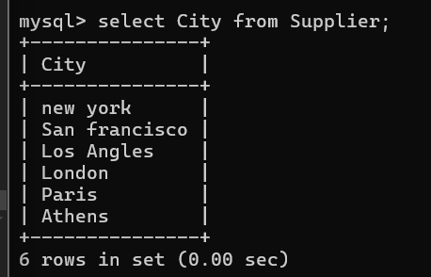

**15. Assuming that the Part Weight is in GRAMS, display the same in MILLIGRAMS and KILOGRAMS.**

mysql> select Pname,

-> Weight As Weight_in_grams,

-> Weight*1000 As Weight_in_miligrams, //(1 gram = 1000 milligrams)

-> Weight/1000 As Weight_in_kilograms //(1 kg = 1000 grams)

-> from parts;

